Soil Moisture Effects on Portable X-ray Fluorescence Spectroscopy and Visible-Near Infrared Spectroscopy Measurements

By Sean Fischer*, Alfred E. Hartemink, Yakun Zhang, Jenifer L. Yost

ABSTRACT
Portable X-ray fluorescence (pXRF) and visible-near infrared spectroscopy (vis-NIR) are used to measure or predict soil properties such as soil organic carbon, nutrients, soil texture, and environmental pollutants such as heavy metals. These characteristics have great importance in soils under agriculture as well as environmental remediation. When taken in the field, vis-NIR and pXRF measurements are affected by the moisture conditions of the soil. This study seeks to quantify the effects of soil moisture on pXRF and vis-NIR measurements and propose correction equations of moisture effects. Topsoil and subsoil samples from an Entisol (~sand) and a Mollisol (~silty loam) were wetted in the laboratory to six different moisture contents, and subsequently scanned by the pXRF and vis-NIR. The elemental intensity in spectra from the pXRF was significantly reduced by higher moisture contents, yielding lower elemental concentrations. This was linearly related to gravimetric water content. The effect was stronger in the silty loam soils than in the sandy soils. The reflectance of vis-NIR spectra decreased with increasing soil moisture content, and the reduction in reflectance of two spectral ranges (1410-1450 and 1910-1930 nm) was modeled by non-linear logarithmic regression. It is concluded that soil moisture reduces the measurements of pXRF and reflectance spectra of vis-NIR. The elemental concentrations measured by pXRF could be corrected by linear model with known gravimetric water content, whereas more sophisticated models are needed for vis-NIR spectra. The results of this study may improve the accuracy of pXRF and vis-NIR spectroscopy soil analysis used in the field, and could influence the way soil data is collected.

INTRODUCTION
Soil measurements are often costly and time-intensive [1], and there is a need for quicker and more accurate techniques to measure soil properties in the field [2]. Soil information is needed for precision agriculture, modeling, and other soil management that requires large amounts of accurate soil data. These management activities are important to a variety of industries, including agriculture. However, a great volume of spatial data is needed for this management. Proximal soil sensors collect data rapidly and are a cost-effective alternative to traditional, outsourced laboratory analysis [3]. Proximal soil sensing is defined as the use of field-based sensing equipment to, directly and indirectly, obtain data about properties of the soil [4]. Proximal soil sensing allows for faster and greater collection of data points, enabling large amounts of spatial data across broad areas to be collected to fill industry needs. Although individual sensor measurements may not be as accurate as traditional analysis, more data can be collected and thus more information on the soil resource is provided. This study attempts to improve the accuracy of field measurements of pXRF and vis-NIR proximal sensors by studying the possible correction of the effects of moisture on field measurements.
Portable X-ray fluorescence (pXRF) spectrometer and visible near-infrared (vis-NIR) spectrometer are two examples of proximal sensors. The pXRF gives estimates of total elemental concentrations in the soil (i.e., Mg, Si, Al and Ca). This is accomplished through the ionization of electrons of elements in the soil and the subsequent interpretation of properties of photo-electrons emitted following ionization [5]. Knowledge of elemental concentrations can be used in the diagnosis of contaminated soils or nutrient deficiencies. pXRF has also been used to characterize soil horizons, which are definable layers in the soil associated with soil properties [6, 7, 8].
The vis-NIR measures the diffuse reflectance of the soil in the visible and near-infrared portions (350-2500 nm) of the electromagnetic spectrum [9]. Spectral graphs are produced from measurements which can be analyzed to indirectly acquire information about soil properties, including soil organic carbon (SOC) concentration, texture, or moisture content [9, 10]. Both pXRF and vis-NIR spectrometers are especially useful because of their portability and ability to be used in the field.
Measurements collected from the vis-NIR and pXRF are affected by soil moisture. In vis-NIR analyses soil moisture absorbs visible and near-infrared light, causing a decrease of reflectance in the vis-NIR spectra. In X-ray fluorescence soil moisture causes a linear decrease in the intensity (amplitude) of photoelectrons emitted by the soil [12]. This results in lower measured elemental concentrations [13], and the degree of this effect varies between elements, soil texture, and soil types [5]. The effect of soil moisture conditions on these measurements remains to be quantified for different soils. Effects of moisture in different soils must be measured because of the variability of soils, which could affect sensor results differently.
In this paper, the effects of soil moisture on elemental concentrations and reflectance spectra using pXRF and vis-NIR spectrometers was investigated in two soils with contrasting textures. The objectives of this research were to: (i) determine the variation in elemental concentrations and reflectance spectra with varying soil water contents, and (ii) develop a function to correct for soil moisture effects on pXRF and vis-NIR measurements.

METHODS

The soils
Two soils from Wisconsin were used in this experiment: an Entisol (Soil series name: Plainfield sand; Classification: mixed, mesic Typic Udipsamments) and a Mollisol (Soil series name: Troxel silt loam; Classification: fine-silty, mixed, superactive, mesic Pachic Argiudolls). Entisols are recently formed soils, usually with a relatively thin topsoil layer. Mollisols are soils that have a thick topsoil and properties useful in agriculture.
The Entisol (sand) was collected from Wallendal Farms in the Wisconsin Central Sand Plains (WGS84 43.91°N, 89.68°W) at an elevation of approximately 311 meters. The soil was under agriculture at the time of sampling. The soil is excessively drained and sandy throughout and was formed in a sandy drift on glacial outwash plains. Mean annual precipitation is about 833 mm. Typical horizons are Ap (0-24 cm), Bw1 (24-55 cm), Bw2 (55-110 cm), C (110+ cm).
The Mollisol (silty loam) was located at University of Wisconsin West Madison Agricultural Research Station in south-central Wisconsin (WGS84 43.07°N, 89.54°W). The soil was formed in windblown deposits over a glacial outwash plain which was underlain by dolostone bedrock (approximately 3 m). The soil was moderately well-drained to well-drained and was under grassland at the time of sampling. Six horizons were identified in the field: Ap (0-20 cm), A2 (20-55 cm), Ab (55-62 cm), E (62-70 cm), Bt1 (70-85 cm), and Bt2 (85-102 cm).
For each soil, topsoil (0-10 cm for Entisol, 0-9 cm for Mollisol) and subsoil (40-50 cm for Entisol, 99-102 cm for Mollisol) were selected. In the Entisol, the texture was uniform throughout the profile, with approximately 91% sand, 7% silt, and 4% clay content. SOC and pH decreased with depth (2.4% to 0.2% SOC; pH 6.4 to 5.8). In the Mollisol, the topsoil had approximately 13% sand, 67% silt, and 20% clay content and pH and SOC decreased with depth (2.8% to 0.3%; pH 7.1 to 5.5). The subsoil in the Mollisol had approximately 8% sand, 61% silt, and 31% clay content.

pXRF measurements
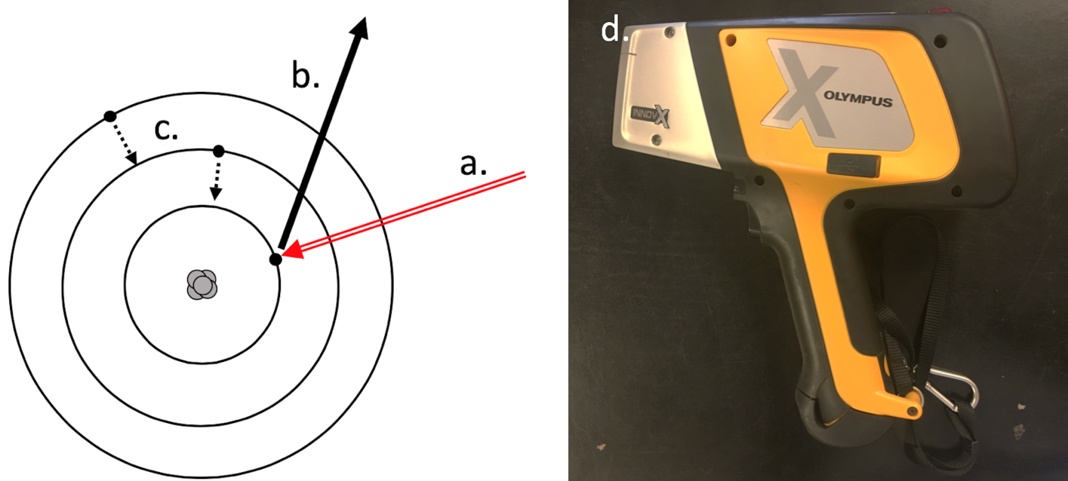
Figure 1: Mechanics of portable x-ray fluorescence (pXRF) spectrometry. An x-ray photon (a) emitted by a pXRF machine ejects an inner-shell electron (b), causing a cascade effect for the electrons in the outer shells to fall inward (c). Photograph of the portable X-ray fluorescence spectrometer used (d).
Portable X-ray fluorescence spectroscopy nondestructively measures the presence and abundance of multiple elements in a sample simultaneously by using X-ray fluorescence [5]. The process involves X-rays being generated within an X-ray tube inside the pXRF, and then directed at the soil surface. Energy is released and is measured by the pXRF as fluorescence. By measuring the frequency of the energy emitted, the pXRF can determine the types of elements struck by the X-rays. By measuring the intensity (or amplitude) of different waves, the pXRF can estimate the amount of those elements present in the sample in parts per million [5].
The elemental (Zn, Ti, Ni, Fe, Zr, Sr, Mn, and Cu) concentrations were determined by using a Delta Premium portable X-ray fluorescence (pXRF) spectrometer (Olympus Scientific Solutions Americas Inc., Waltham, MA). The Geochem mode was used in this study and operated for a duration of 60 s in a two-beam configuration at 40 and 10 kV [17]. The spectrometer was calibrated using a 316-stainless steel calibration check coupon prior to taking measurements. The elemental concentrations were measured using an internal factory-installed calibration procedure (the Compton normalization method) [17].

vis-NIR spectroscopy
Visible-near infrared diffuse reflectance spectroscopy provides information about the soil by measuring the light it reflects in the visible and near-infrared parts (350-2500 nm) of the electromagnetic spectrum. Radiation with frequencies corresponding to these parts of the spectrum is directed at a sample. The spectrometer reads the diffuse reflected light that was not absorbed by the sample and computes a percent reflectance value for each wavelength in the range 350-2500 nm. These values can be plotted as a spectral curve. This curve can be analyzed to gain information about important soil properties such as soil minerology, carbon content, soil texture, and soil moisture characteristics [9].
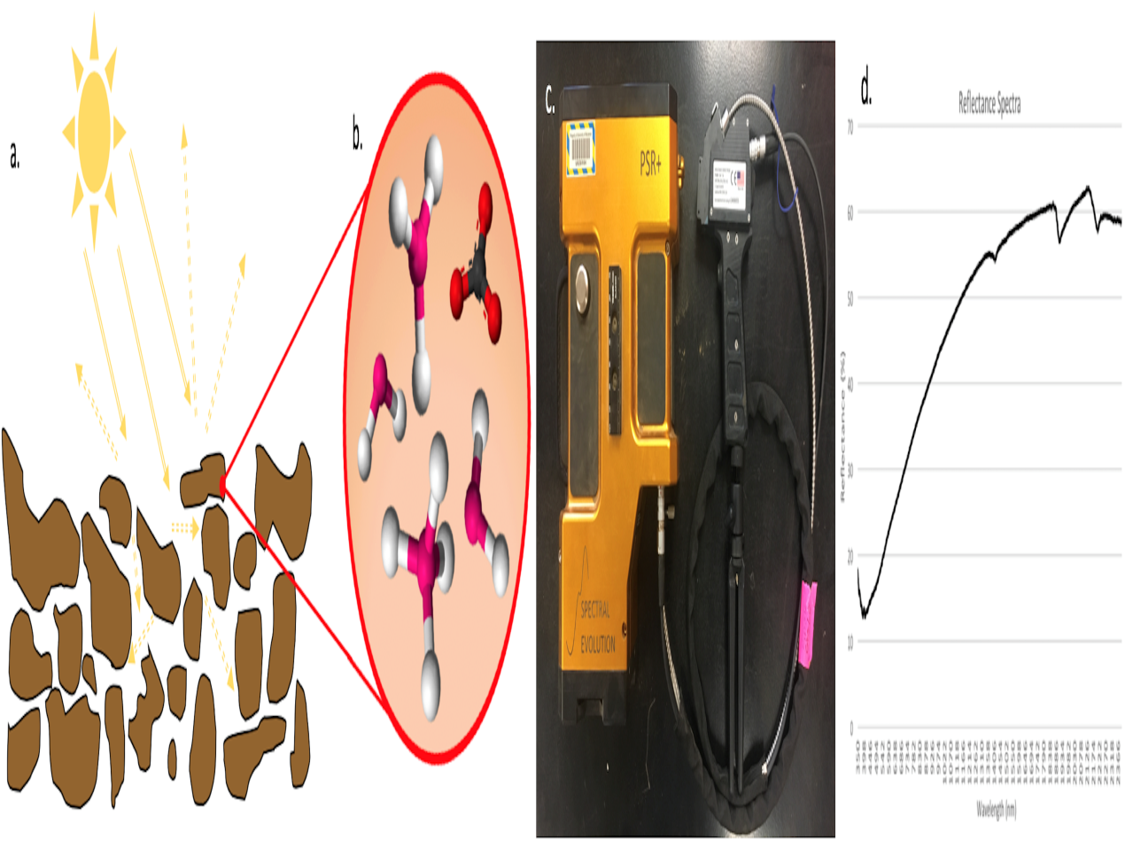
Figure 2: Photograph of the visual-near infrared spectrometer used (a). Example of a reflectance spectra produced by the vis-NIR spectrometer (b).
A PSR-3500 spectrometer (Spectral Evolution, Lawrence, MA) was used to scan the samples in the laboratory. The vis-NIR operates in the range of 350-2500 nm with three detectors: 1) a 512-element silicon PDA covering the visible range and part of the near infrared (350-1000 nm) with a resolution of 3 nm; 2) a 256-element InGaAs array covering 1000-1900 nm with a resolution of 8 nm; and 3) a 256-element InGaAs array covering 1900-2500 nm with a finer spectral resolution of 6 nm. The reflectance data were resampled to 1 nm for output and this results in 2151 spectral points. The reflectance spectrum was recorded by averaging 30 readings per soil sample measurement, and three replicates were taken for each sample by repositioning the probe between each scan. The vis-NIR was calibrated by a white plate made of polytetrafluoroethylene and was recalibrated every 10 samples. Continuum removal technique was applied to the reflectance spectra using the “prospectr” package [14] in R version 3.4.3 [15] to remove the general trend of the spectra and sharpen major absorption features.

Experimental design
The four soil samples (Entisol topsoil 0-10 cm depth, Entisol subsoil 10-50 cm depth, Mollisol topsoil 0-9 cm, and Mollisol subsoil 99-102 cm) were air-dried, ground, and passed through a 2-mm mesh sieve. Each sample was split into six subsamples with three replicates to achieve six gradients of water contents. Each replicate contained 25 g of soil, which ensured a minimum soil depth of 5 mm for the scan. The Entisol samples (sand) received 0, 1, 2, 3, 4, and 5 ml of deionized water, while the Mollisol samples (silt loam) received 0, 2, 4, 6, 8, and 10 ml of deionized water. All samples were sealed in plastic wrap and left for 24 hours in order for moisture to spread in the soil sample.
Each replicate was weighed and scanned using the pXRF and the vis-NIR spectrometers. Samples were transferred to metal containers and oven-dried at 105°C for 24 hours. The oven-dried samples were weighed and the gravimetric water content ( was calculated as follows:
θ_m = ((wet weight) – (dry weight)) / ((dry weight)) = (mass of water)/(mass of oven-dried soil)

Data analysis
The relationship between elemental concentration and gravimetric water content was studied for each of the elements: Ni, Mn, Fe, Ti, Cu, Zn, Sr, and Zr in every soil sample (Entisol topsoil, Entisol subsoil, Mollisol topsoil, Mollisol subsoil). The coefficient of determination (R²) was calculated to quantify the fit of the trendlines created. A linear model for pXRF was used because of success correcting results in past studies [12]. The continuum removed spectra for vis-NIR were averaged over three ranges of gravimetric water contents (<6%, 10-25%, 25-40%). The nonlinear relationship between the reflectance reduction at two major troughs from 1410-1450 nm and 1910-1930 nm were studied for the mean spectra of the three replicates and the R² was calculated for every soil sample.

RESULTS

Moisture effects on pXRF
Soil moisture reduced the pXRF measurements in both soils. All elemental concentrations were lower in the Entisol (Fig. 3) than in the Mollisol (Fig. 4) at similar moisture contents. Measured elemental concentrations decreased linearly with increasing moisture content in both the topsoil and subsoil for the Entisol for most elements (Fig. 3). In the Mollisol, the elemental concentrations decreased linearly with increased moisture content for all elements (Fig. 4). In the Entisol, Ni, Sr, Zr, and Cu displayed poor correlation in the topsoil, subsoil, or in both, while Mn, Ti, Fe, and Zn were slightly correlated (R² > 0.2) (Fig. 3). Stronger correlations were observed in the Mollisol, and the subsoil tended to have stronger correlations than in the topsoil. In general, there was greater variation in the Entisol than in the Mollisol. The best-fit line was linear and established the relationship between gravimetric water content and elemental concentrations (Tables 1 and 2).]
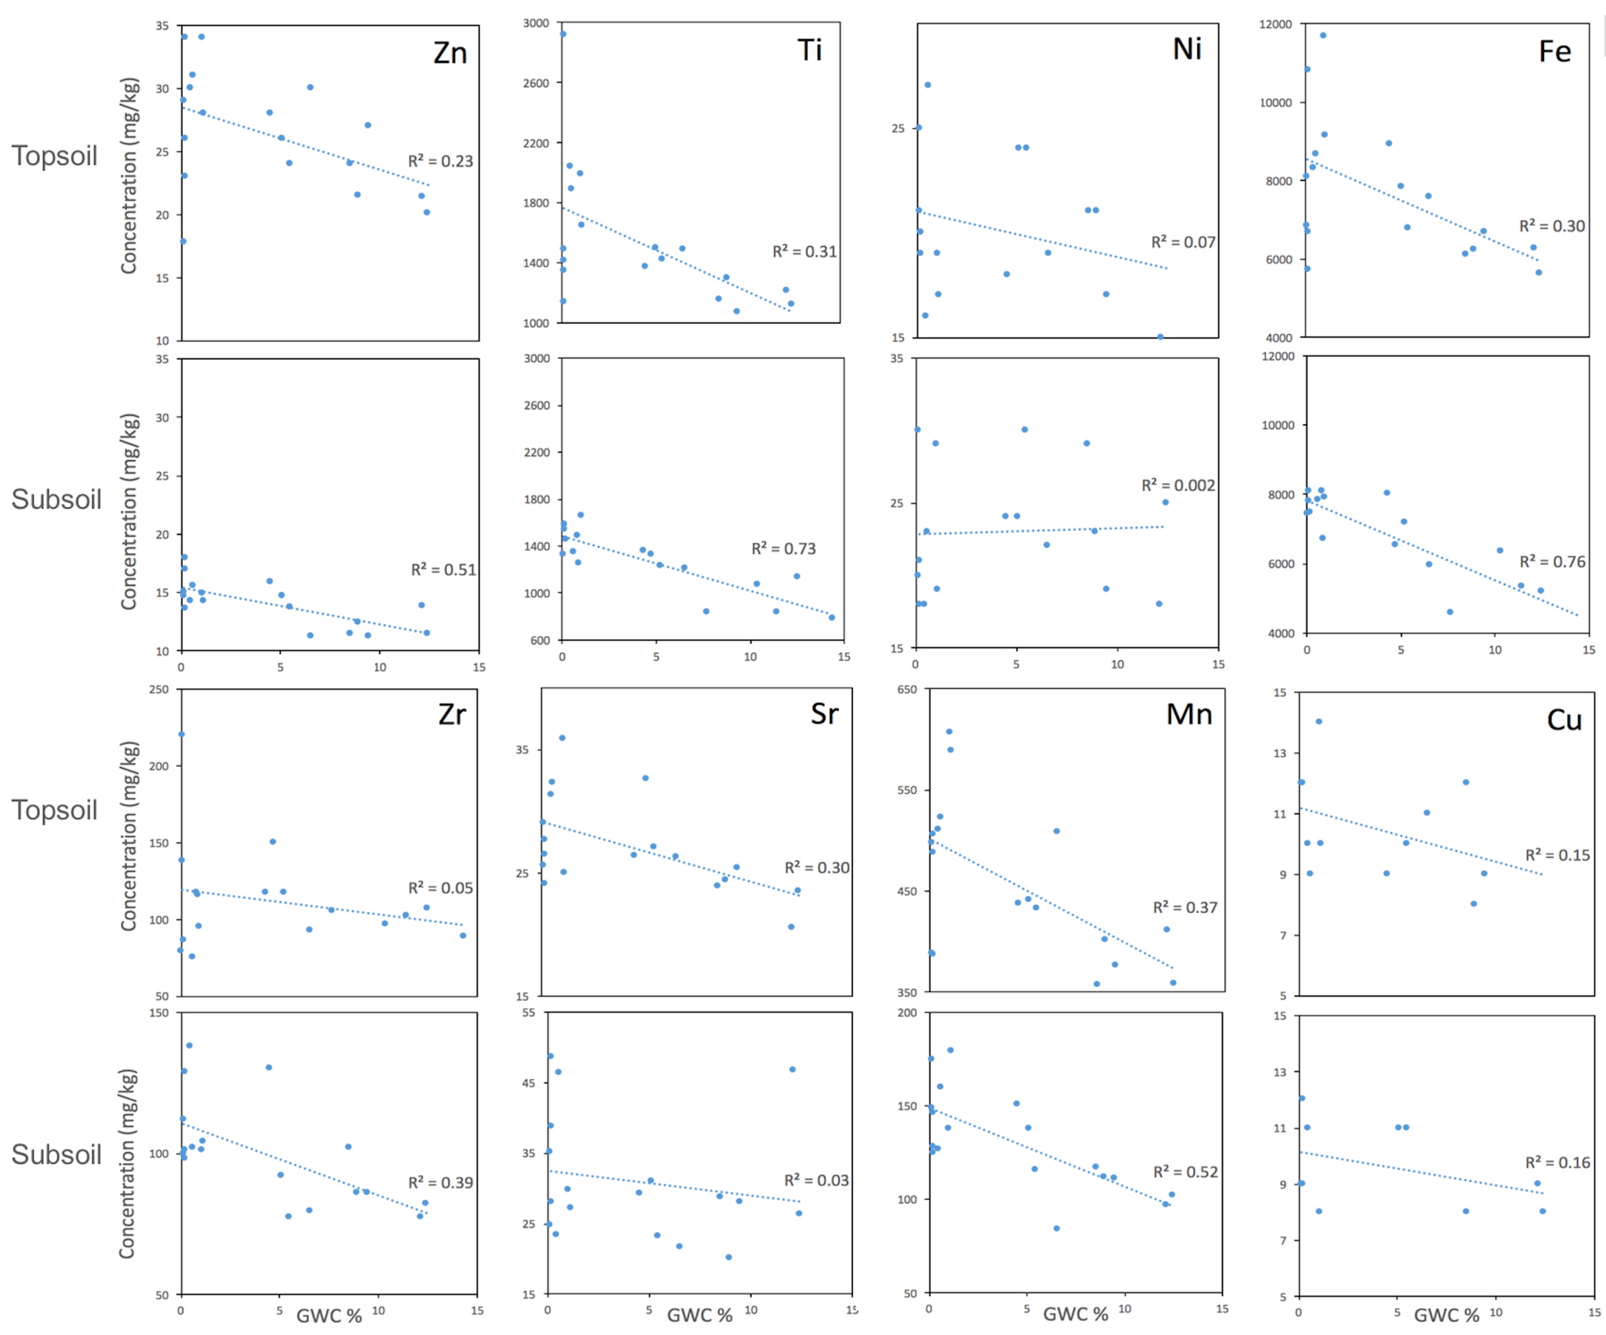
Figure 3. Topsoil (0-10 cm depth) and subsoil (40-50 cm depth) elemental concentrations by varying gravimetric water content (GWC) for the Entisol.
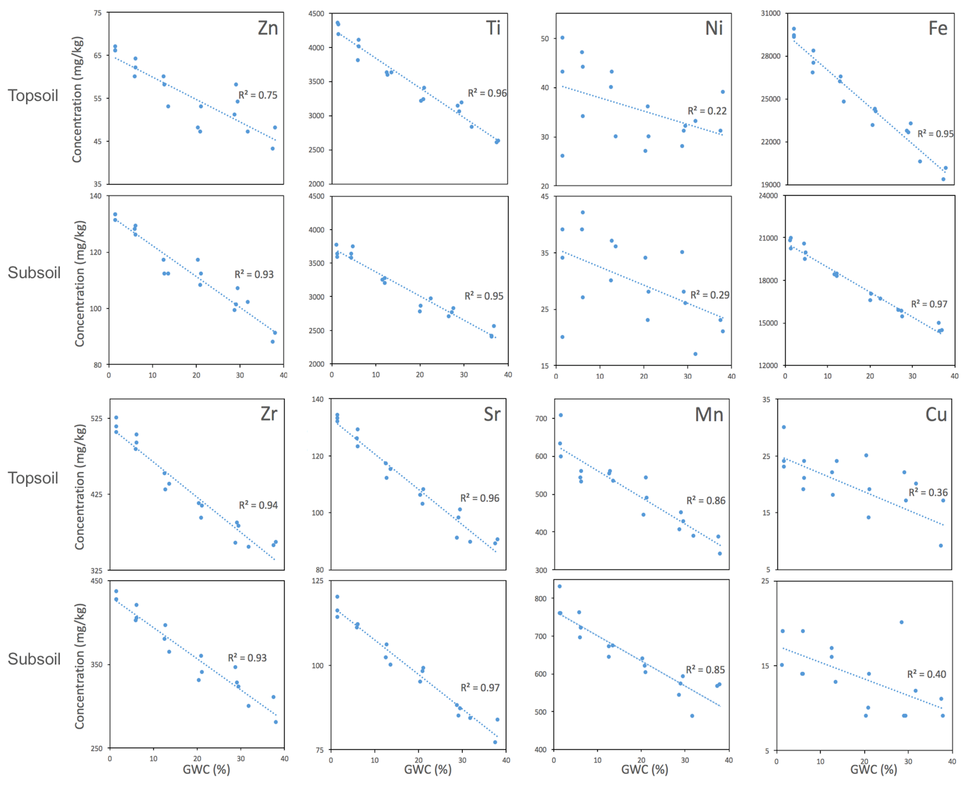
Figure 4. Topsoil (0-9 cm depth) and subsoil (99-102 cm depth) elemental concentrations by varying gravimetric water content (GWC) for the Mollisol.
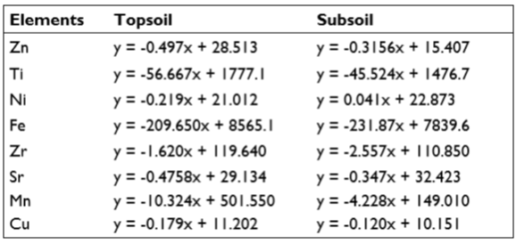
Table 1. Linear relationships between elemental concentration and gravimetric water content for the Entisol.
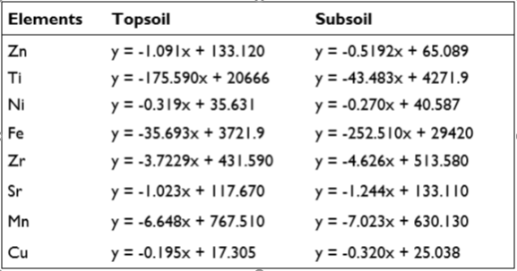
Table 2. Linear relationships between elemental concentration and gravimetric water content for the Mollisol.

Moisture effects on Vis-NIR spectroscopy
The reflectance of the soil decreased with increasing soil moisture in the topsoil and subsoil of both soils (Fig. 5). In the topsoil, soil moisture influenced the reflectance between 350-1000, 1350-1700, and 1700-2200 nm. In the subsoil, soil moisture influenced the reflectance between 1350-1700, 1700-2200, and 2300-2500 nm. Between 1300-2200 and 2200-2500 nm, the reflectance decreased more in the subsoils than in the topsoils with increasing soil moisture. However, in the visible wavelength (350-700 nm), the moisture effect was less in the subsoils.
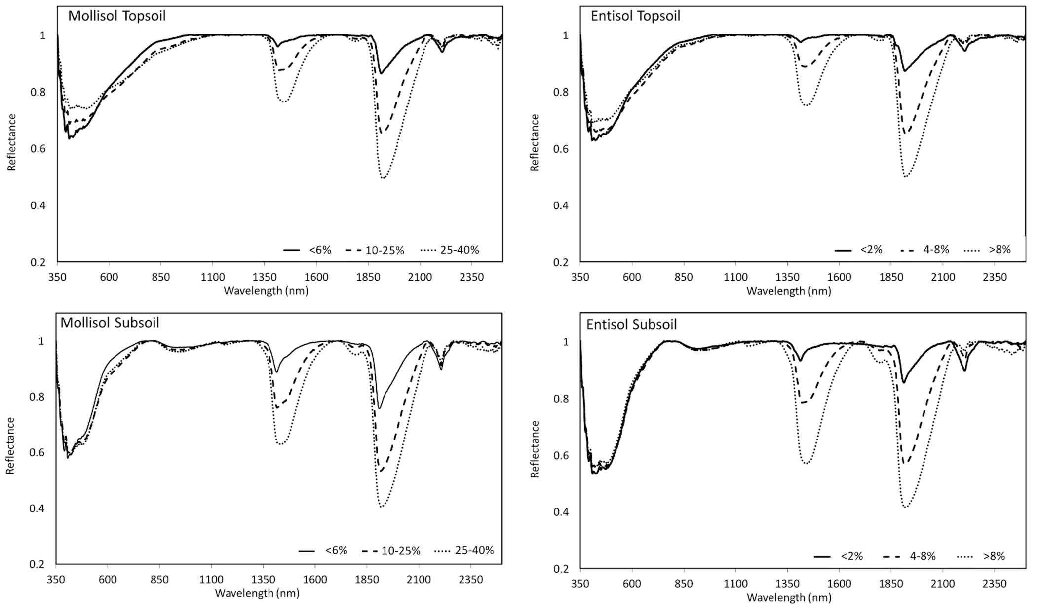
Figure 5. Continuum-removed soil reflectance spectra in the visible-rear infrared wavelength range (350-2500 nm) at three different gravimetric water content ranges for the Entisol (topsoil: 0-10 cm depth, subsoil: 40-50 cm depth) and Mollisol (topsoil: 0-9 cm depth, subsoil: 99-102 cm depth).
The reduction in reflectance from maximum reflection (equal to “1”) was plotted for the two wavelength ranges (1410-1440 nm and 1910-1930 nm) which experienced the greatest changes due to moisture (Fig. 6). A logarithmic best fit line was applied to each of these plots, indicating that as soil moisture increases, reflection is reduced less than at lower moisture levels.
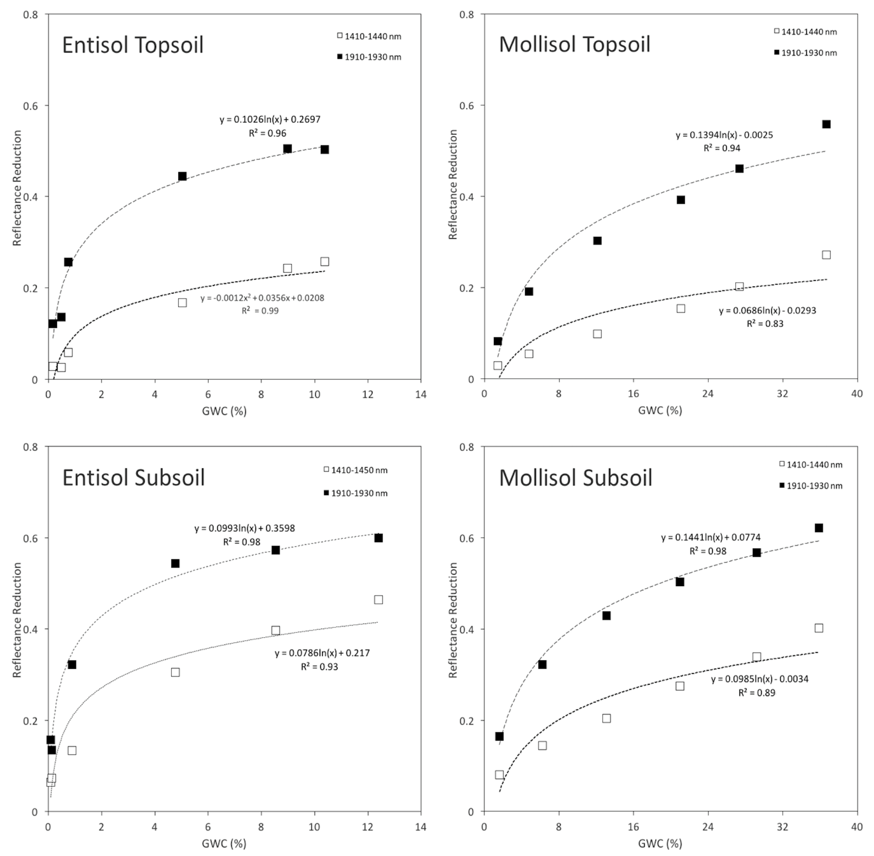
Figure 6. Measured reduction in reflectance at two wavelength ranges (1410-1440 nm and 1910-1930 nm) as affected by gravimetric water content (GWC %) for the Entisol (topsoil: 0-10 cm depth, subsoil: 40-50 cm depth) and Mollisol (topsoil: 0-9 cm depth, subsoil: 99-102 cm depth).

DISCUSSION

pXRF
A decrease in elemental concentrations (decrease in X-ray intensity) was observed as a result of increased moisture content. Moisture is known to affect pXRF measurements in two ways: 1) water enhances a substance’s absorption of X-rays, resulting in decreased intensity, and 2) water particles cause X-ray scattering which increases X-ray intensity [12]. Results from this study indicate that the former effect is more pronounced than the latter, and can significantly decrease X-ray intensity, leading to a decrease in elemental concentrations.
Limited correlations between soil moisture and measured elemental concentrations in the Entisol might be due to the high content of sand in the soil. Coarser-textured soils tend to cause higher variability in elemental concentrations than in finer-textured soils [5]. Sand has low water holding capacity and can lose moisture quickly to evaporation. Evaporation during the experiment may have been higher in the sandy soils than in the silty loam soils, causing higher variability in the sandy soils.

Vis-NIR spectroscopy
The results found in this study agree with those presented in Stenberg et al. [9] and Minasny et al. [11] that absorbance in the 1400 nm and 1900 nm areas are affected by soil moisture, resulting in a decrease in reflectance. The reflectance decreased due to O-H bond stretching and bending in response to the light energy [9]. Water generally decreases the albedo of most surfaces due to an increase in light refraction as the photons pass through films of water which form on the surfaces. This creates a scattering effect, increasing the path of travel of the photons and further increasing the chances that the light will be absorbed [9].
Soil moisture had an effect on the results for topsoil measurements in the visible range but did not have a considerable effect in the subsoils, as can be seen in Fig. 5 between 350-600 nm. The reason for this could be linked to higher soil organic carbon (SOC) concentrations in the topsoil, where SOC responds with a decrease in reflectance with increased soil moisture [9].

Correction function
An empirical correction function may be found for pXRF results, enabling more accurate measurements in the field. Achieving higher accuracy with pXRF in situ has broad implications for soil science. For example, spatial distributions of soil nutrients under agricultural land could be developed efficiently, allowing fertilization and other soil remediation activities to occur with precision. The pXRF inference models for improved accuracy could be developed easily because of the linear relationship between decreasing intensity and soil moisture. Stockmann et al. [12] used 10 subsamples from a Dermosol to derive a correction function for Fe using linear regression and applied it to successfully correct the measurements of 120 samples taken in situ. A similar correction can be done for the soils studied here with known gravimetric water content (Table 1 and Table 2) since the elemental concentration decreased linearly with increasing water content. This study created correction functions for Fe concentrations, as well as 7 additional elements not studied in Stockman et al. [12]. A correction function for the Mollisol would be highly accurate, as can be seen in the high R² values of the regressions, while the correction for the Entisol would not be as accurate, as can be seen in the low R² values of the regressions.
Vis-NIR results skewed by soil moisture can be corrected through complex nonlinear analysis, greatly assisting measurements in the field. The effect on absorbance varies between soils due to differing mineralogy, complicating corrections [9]. Minasny et al. [11] and Ge et al. [16] have used external parameter orthogonalization (EPO) to successfully remove the moisture effects. In this study EPO was not used, instead the reflectance of two spectral ranges (1410-1450 and 1910-1930 nm) was described using logarithmic regression with known gravimetric water content. This model was successful in describing the moisture effects in these ranges, shown in the high R² values of regressions in Figure 6.

CONCLUSIONS
Soil moisture content affects pXRF and vis-NIR measurements. The elemental intensity in spectra given by pXRF was reduced by higher moisture contents, yielding lower elemental concentrations. The reflectance of vis-NIR spectra decreased with increasing soil moisture content due to higher absorbance of light by the vibration of water molecules. The elemental concentrations were shown to have linear relationships with gravimetric water content, and the effect was more pronounced in the silt loam soils (Mollisol) than in the sandy soils (Entisol). The linear regression could be used to correct for elemental concentrations with known gravimetric water content. The vis-NIR spectra of two spectral ranges (1410-1450 and 1910-1930 nm) had a nonlinear correlation with gravimetric water content which may need more sophisticated correction methods to account for the soil moisture effects.
In the future, these instruments could be further developed to perform corrections in situ following calibration from site-specific samples. High-resolution soil data could be gathered efficiently, greatly assisting management activities requiring soil data.

ACKNOWLEDGEMENTS
We would like to thank the F.D. Hole Soil Lab for making this research possible.

REFERENCES
- Adamchuk, V., Viscarra Rossel, R. Development of on-the-go proximal soil sensor systems. Proximal soil sensing. Springer. 2010; pp. 15-28.
- Viscarra Rossel, R.A.V., McBratney, A.B., Minasny, B. Proximal soil sensing. Springer. 2010.
- Sahraoui, H., Hachicha, M. Effect of soil moisture on trace elements concentrations using portable X-ray fluorescence spectrometer. JOURNAL 2017; 9(1): 17.
- Viscarra Rossel, R.A., Adamchuk, V.I., Sudduth, K.A., McKenzie, N.J., Lobsey, C. Proximal Soil Sensing: An Effective Approach for Soil Measurements in Space and Time. Advances in Agronomy. 2011; 113: 243-291.
- Weindorf, D.C., Bakr, N., Zhu, Y. Advances in Portable X-ray Fluorescence (pXRF) for Environmental, Pedological, and Agronomic Applications. Advances in Agronomy. 2014; 128: 1-45.
- Grauer-Gray, J., Hartemink, A.E., Raster sampling of soil profiles. Geoderma. 2018; 318: 99-108.
- Weindorf, D.C., Zhu, Y., McDaniel, P., Valerio, M., Lynn, L., Michaelson, G., Clark, M., Ping, C.L. Characterizing soils via portable X-ray fluorescence spectrometer: 2. Spodic and Albic horizons. Geoderma. 2012; 189–190: 268-277.
- Zhu, Y., Weindorf, D.C., Zhang, W. Characterizing soils using a portable X-ray fluorescence spectrometer: 1. Soil texture. Geoderma. 2011; 167–168: 167-177.
- Stenberg, B., Viscarra Rossel, R.A., Mouazen, A.M., Wetterlind, J. Visible and near infrared spectroscopy in soil science. Advances in Agronomy. 2010; 107: 163-215.
- Zhang, Y., Hartemink, A.E. Sampling designs for soil organic carbon stock assessment of soil profiles. Geoderma. , 2017; 307: 220-230.
- Minasny, B., McBratney, A.B., Bellon-Maurel, V., Roger, J.-M., Gobrecht, A., Ferrand, L., Joalland, S. Removing the effect of soil moisture from NIR diffuse reflectance spectra for the prediction of soil organic carbon. Geoderma. 2011; 167–168: 118-124.
- Stockmann, U., Jang, H.J., Minasny, B., McBratney, A.B. The Effect of Soil Moisture and Texture on Fe Concentration Using Portable X-Ray Fluorescence Spectrometers. In: A.E. Hartemink, B. Minasny (Eds.), Digital Soil Morphometrics. Springer, Dordrecht. 2016; pp. 63-71.
- Santana, M. L. T. Rieberto, B. T., Silva S. H. G., Poggere, G. C., Guilherme, L. R. G., and Curi, N. Conditions affecting oxide quantification in unknown tropical soils via handheld X-ray fluorescence spectrometer. CSIRO Publishing. 2018.
- Stevens, A., Ramirez-Lopez, L., Stevens, M.A., Rcpp, L. Prospectr: Miscellaneous functions for processing and sample selection of vis-NIR diffuse reflectance data. 2013; R package version 0. 1. 3, pp. 32.
- R Core Team. R: A Language and Environment for Statistical Computing, Vienna, Austria. 2016. (At: http://www.R-project.org/).
- Ge, Y.F., Morgan, C.L.S., Ackerson, J.P. VisNIR spectra of dried ground soils predict properties of soils scanned moist and intact. Geoderma. 2014; 221: 61-69.
- 2012. DELTA Family Handheld XRF Analyzer: User Interface Guide. Waltham, MA: Olympus NDT.

This piece was featured in Volume IV Issue I of JUST.

